UID-EXPERIMENT -2

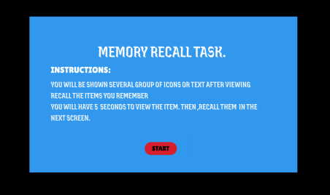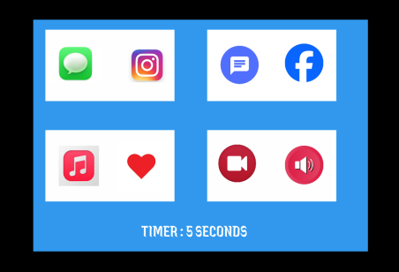

● The second screen displays chunked items, either grouped with borders or placed freely.

● This phase helps analyze how chunking affects memory retention.

● The system automatically transitions to the next phase after 5 seconds, simulating a fixed viewing time for the displayed items.

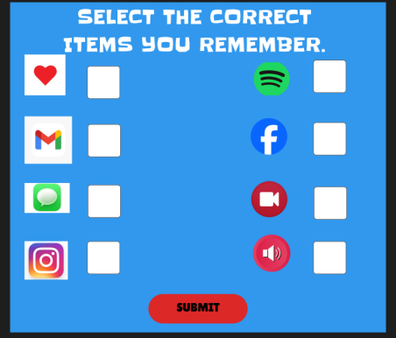● This screen is used to submit the answers.

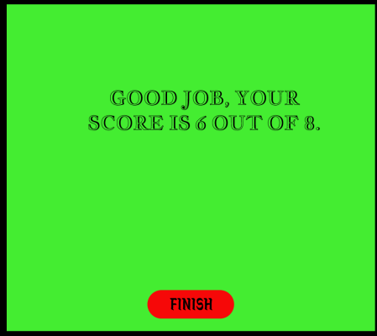

● After finishing the task, feedback is displayed showing how many items were recalled correctly.

DONE BY: 230701274